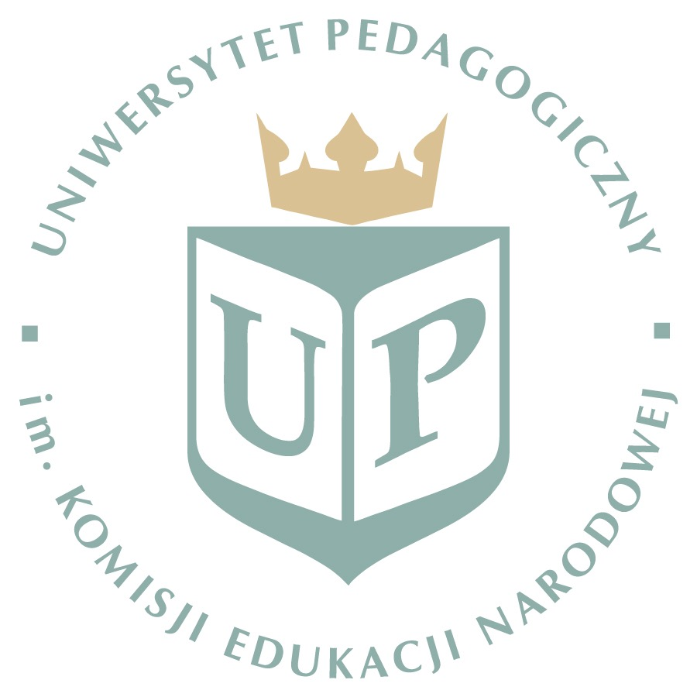

Pedagogical University of Cracow
28-29.04. 2020

10th International Seminar ‘Science-Society-Didactics’(SSD)
„Role of teacher in the real and virtual world”.
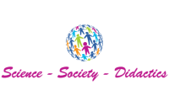

Registration form

Name, surname
Institution:
Address
Tel: |  |  |  | E-mail:
form | Active / non active |  |  | form | paper / poster

In case of active participation specify the title of your contribution:

————————————————————————————————————————————————————-

Registration form send to: potyrala2@wp.pl

