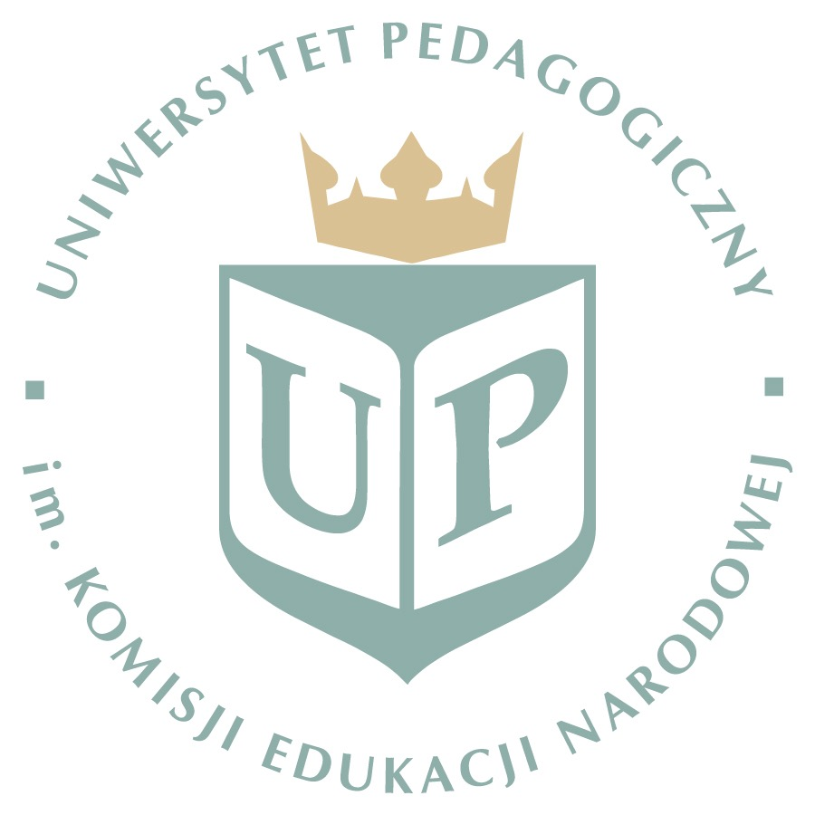

Pedagogical University of Cracow
28-29.04. 2020

10th International Seminar ‘Science-Society-Didactic’(SSD)
„Role of teacher in the real and virtual world”

Registration form

Name, surname
Institution
Address
Tel. |  | E-mail:
Form of  participation | Active / non active | Form of  presenting | paper / poster / key speaker

In case of active participation specify the title of your contribution:

————————————————————————————————————————————————————-

If you wish to participate as a key speaker, please concider that the keynote should be about 25 minutes long (plus 5 minutes for discussion), focus on the conference theme “ Role of teacher in the real and virtual world “ and present an innovative study (doctoral thesis or other) in which you participate as researchers. The winner will be invited to present his or her keynote during the conference. Proposals for the keynote, which are not selected but meet the review criteria, will be accepted in a shortened version as paper presentations.
The proposal for keynote should consist of:
• Title and abstract of the keynote (300 words, incl. ref.)
• 3 keywords
• A working paper: 1000 words (incl. ref.)
• A short CV including academic track record

Registration form send to: konferencja.mso.2018@gmail.com

